**Technical Documentation – Refresh_ONLINE_BATCH_Forms_Reports_Environments**

1. Workflow – Refreshes FAR Environments from one environment to another. This is used for all environments other than MUAT/MAINT and IPASP/Production. The MUAT/MAINT and IPASP/Production are updated with Release_ONLINE_BATCH_Forms_Reports_to_MUAT and Release_ONLINE_BATCH_Forms_Reports_to_IPASP workflows.

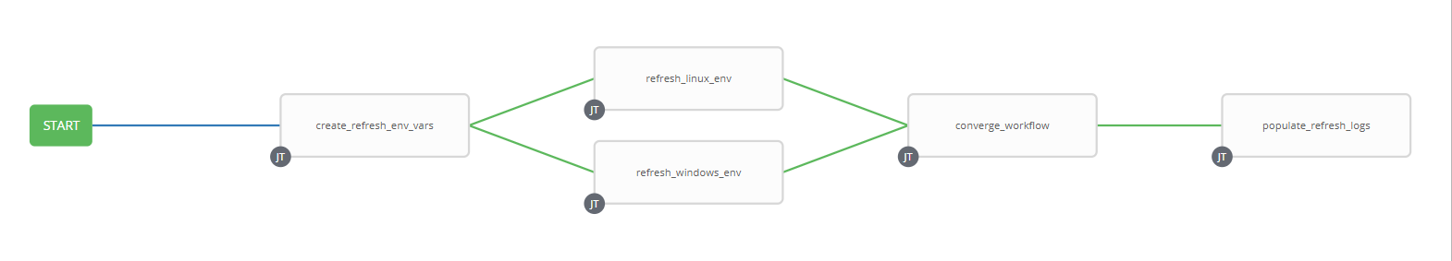

1. Survey – User Supplied Variables

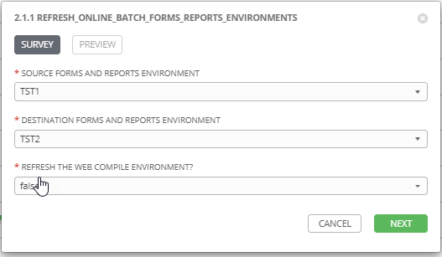

|  |  |  |  |
| --- | --- | --- | --- |
| **Survey Extra Variables** | **Prompt** | **Type** | **Description and Usage** |
| SOURCE | Source Forms and Reports Environment | Multiple Choice Single Pick | Environment to copy FAR Artifacts FROM (DEV3, DEVL, RDEV, TST1, TST2, TST3, TRNM, TRNG, MUAT). |
| DESTINATION | Destination Forms and Reports Environment | Multiple Choice Single Pick | Environment to copy FAR Artifacts TO (DEV3, DEVL, RDEV, TST1, TST2, TST3, TRNM, TRNG). |
| REFRESH_WEB | Refresh the Web COMPILE Environments | Multiple Choice Single Pick | true or false (default is false). If this is set to true the WEB Compile environment will be refreshed. The WEB Runtime Environment is resident in the ONLINE Runtime environment for each of the SOURCE and DESTINATION environments above. There is only a single WEB Compile Environment for each of Development, Test, Maintenance and Production. Setting this to True if both the Source and Destination is a Test Environment will result in the COMPILE Environment NOT being refreshed. This is the same if both are Development environments. |

1. Jobs Used by the workflow - http://owl.penc.local:18080/svn/deploy_automation/trunk/Ansible_PlayBooks/FAR

| **Job Template** | **Ansible Playbook** | **Project** | **Description and Usage** |
| --- | --- | --- | --- |
| create_refresh_env_vars | create_refresh_env_vars.yml | FAR Deployments | Destination_Batch_Compile_Directory: \\cronrepdev1\Reports$\defs\dev3  Destination_Online_Compile_Directory: /export_home/codemove/compile/ipas12c/dev3  Destination_Online_Runtime_Directory: /opt/ipas_app_dev/dev3  Destination_WEB_Compile_Directory: /export_home/codemove/compile/ipas12c/webd  Source_Batch_Compile_Directory: \\cronreptest1\Reports$\defs\tst3  Source_Online_Compile_Directory: /export_home/codemove/compile/ipas12c/tst3  Source_Online_Runtime_Directory: /opt/ipas_app_test/tst3  Source_WEB_Compile_Directory: /export_home/codemove/compile/ipas12c/webt  batch_far_server: cronreptest1  date_time: '20200908_1216'  far_server: daulis1bcp  open_chmod: true  stage_server: daulis1bcp  tower_hostname: pdeploy1bcp.penc.local |
| refresh_linux_env | refresh_linux_env.yml | FAR Deployments | Backs up the {{Destination_Online_Compile_Directory}}, {{Destination_Online_Runtime_Directory}} and {{Destination_WEB_Compile_Directory}} Directories and then copies the {{Source_Online_Compile_Directory}}, {{Source_Online_Runtime_Directory}} and {{Source_WEB_Compile_Directory}} (When {{REFRESH_WEB}} is true) to the corresponding Destination Directories.  If the Destination is a Development environment the file and directory attributes are opened up to chmod g+rwx to allow developers to update them. |
| refresh_windows_env | refresh_windows_env.yml | FAR Deployments | Backs up the {{Destination_Batch_Compile_Directory}} and then copies the {{Source_Batch_Compile_Directory}} to {{Destination_Batch_Compile_Directory}}. |
| converge_workflow | converge_workflow.yml | FAR Deployments | A simple convergence job to ensure both refresh_linux_env and refresh_windows_env both complete before proceeding. In earlier versions of Ansible Tower if one converging job completed the next step in the workflow always executed, which is not what we want here. |
| populate_refresh_logs | populate_refresh_logs.yml | FAR Deployments | If both the refresh_windows_env and refresh_linux_env complete successfully create and populate the /codemove_common/dp_automation/refreshes/{{DESTINATION}}_{{Refresh_Date}}DESTINATION}}_Refesh_log.html file. |